**ICAE 02**

**2. Show both collections in table view.**

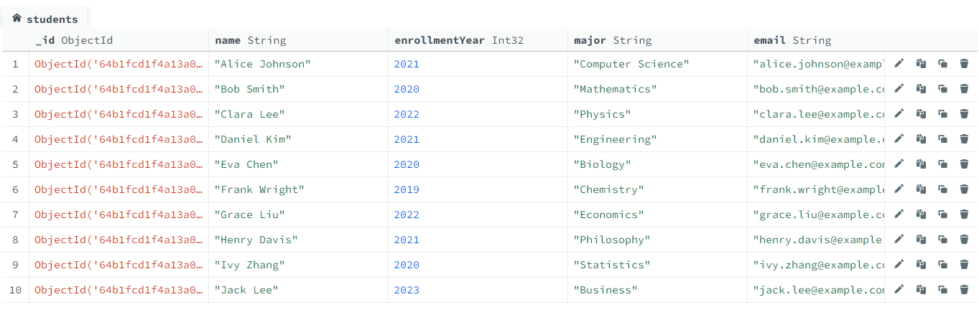

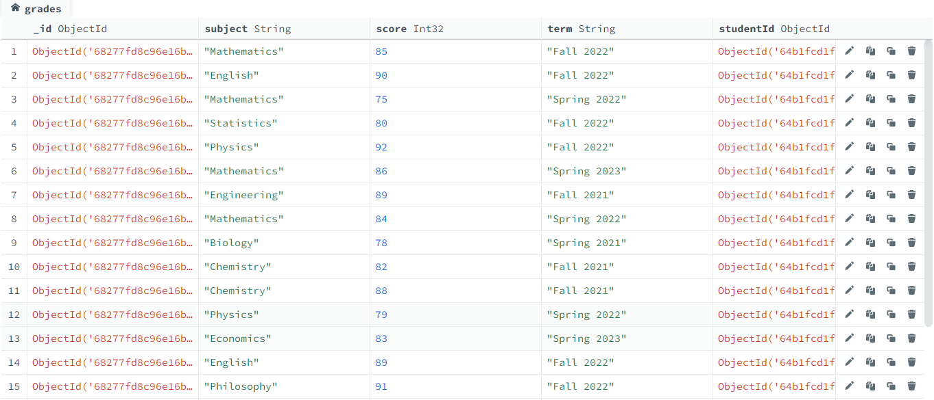

**3. Find the female students and only display their name, age and gender.**

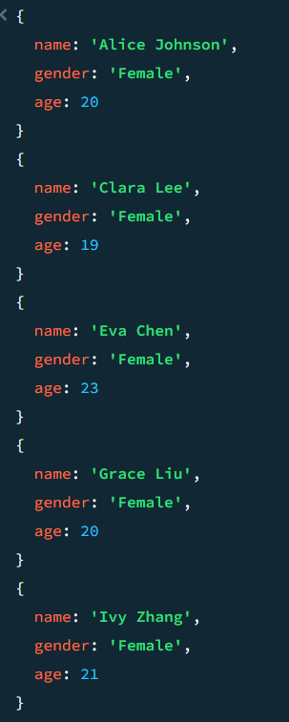db.students.aggregate([

{ $match: { "gender": "Female" } },

{ $project: { _id:0,name: 1, age: 1, gender: 1 } }

])

**4. Find the students who are younger than 22 and enrolled after 2020.**

db.students.find(

{ $and:[ { "age":{$lt:22} },{enrollmentYear:{$gt:2020}}] },

)

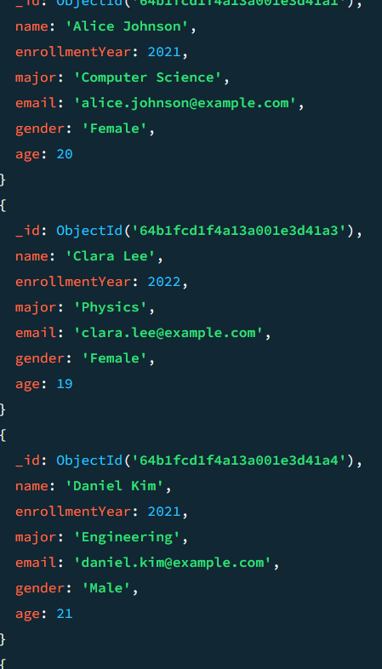

**5. Find all grades for "Alice Johnson".**

db.students.aggregate([

{

$lookup:

{

from: "grades",

localField: "_id",

foreignField: "studentId",

as: "grades"

}

},

{

$match: {"name": "Alice Johnson"}

},

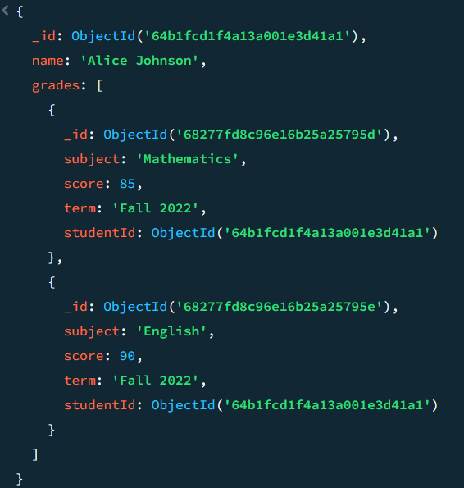{

$project:{

name:1

grades:1

}

}

])

**6. Find how many students followed the subject “Mathematics”.**

db.grades.aggregate([

{

$match:

{"subject":"Mathematics"}

},

{

$group:

{

_id: "$subject",

studentCount: {$sum:1}

}

},

{

$project:

{

_id:0,

subject: "$_id",

studentCount:1

}

}

])

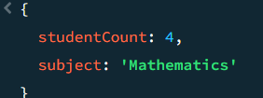

**7. Find all students with grades in the term "Fall 2022".**

db.grades.aggregate([

{

$lookup: {

from: "students",

localField: "studentId",

foreignField: "_id",

as: "students"

}

},

{

$match: {

term: "Fall 2022"

}

},

{

$project: {

students: 1,

term: 1,

studentId: 1,

grade: 1,

subject: 1

}

}

])

